Main Instructions
for
Voices Around The World

Introduction

Voices Around The World
Voices Around The World is a free project with a mission to help young people everywhere work together musically, as well as involving them in a project that raises money to help needy children in different parts of the world. We ask schools to record the students’ vocals and also send us photos and video clips of the work in progress. The eventual song/video release can be purchased as a download when it is released and all the funds raised go directly, to help a schools in Njombe Tanzania and Mombasa in Kenya where many of the young people in the town have been orphaned due to the high HIV prevalence in this part of Africa.

This short booklet gives you all the information needed for different parts of the project. We hope it helps make things straightforward. We recommend that you print out these instructions and keep them for future reference.

The Main Components of the Project
- Rehearsing, recording and submitting group vocals to be part of the international recording
- Recording any strong solo singers individually.
- Making and submitting short video clips/photos of your students rehearsing, recording and/or performing the music – some schools like to video their students performing the song somewhere in the locality of the school
- If possible, linking with other schools nearby you to get them involved in the project.
- Letting us know about how it all went for you either directly or on our Facebook Page! We always love to hear from you in this way. https://www.facebook.com/VoicesAroundTheWorld/

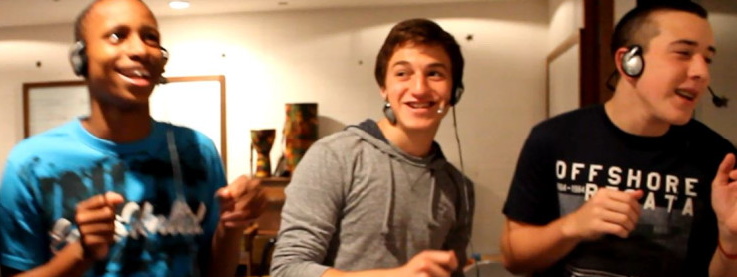
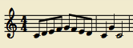
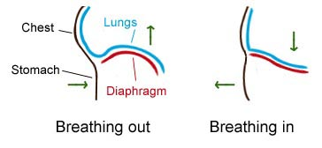
Section 1 – The SingING
Singing tips

It’s really important to allow your singers to warm up their voices before the rehearsal begins. Choose a variety of different starting pitches so that both low and high voices can be warmed up. Here are a few different exercises that you could try…

Singing up and down (or down and up) a major scale using tricky words or tongue twisters – try singing each set of words or each tongue twister to one note at a time. (eg: “Red lorry, yellow lorry” or “Chicken Tikka” or even vowel sounds “A-E-I-O-U”). The more the words move the mouth around, the better!

Singing ‘la’ to a major scale that ascends for five notes, descends back to the starting note
and finishes with three final ‘la’s on the first, fifth and then first note of that scale.

Singing an octave major scale, up and down, using numbers in a pattern. The pattern starts with ‘one’ and adds a number each time, going all the way up to eight. The complete pattern is sung to the corresponding notes in the scale: 1, 1-2-1, 1-2-3-2-1, 1-2-3-4-3-2-1, 1-2-3-4-5-4-3-2-1 etc. Once you have reached ‘eight’, try starting from the end of this pattern and working your way back to the beginning: 8, 8-7-8, 8-7-6-7-8 etc.

It is useful to project the song words onto a board whilst your singers are learning the song. This will ensure that they are looking up, keeping tuning accurate and looking at you – use the downloadable ‘karaoke’ choir part videos from our website www.voicesaround.com The sooner your students know the words by heart the better – it is far easy to teach dynamics once they know the words!

Teach the song in small sections. Ensure that a section of the song is strong and secure before you move onto the next.

A “call-and-response” technique may be useful so that singers can copy you to learn the song.

Always try to keep the rehearsal calm and focused. If you have different voices or parts in your choir, make sure that groups who are not talking whilst one part is rehearsing.

Make sure that rehearsals are not too long. A loss of energy and focus may mean that time has not been used effectively.

If possible let students have access to the downloadable ‘karaoke’ rehearsals videos mentioned above – so that they can learn their choir parts individually at home – this will really speed up your rehearsals!

Make sure your singers breathe in the same places to make the recording sound as “clean” as possible.

Correct breathing involves the diaphragm moving in and out – singers should not move their shoulders to breathe and should rather keep them very still. You can show this to your
singers by asking them
to practice breathing
whilst placing their hand
on their diaphragm.

It’s important that all words are pronounced clearly and that words ending with ‘S’ or ‘T’ are brought off at the same time. Ask singers to watch you for this.

Ask your singers to stand up (straight) when they sing to create the best sound possible. This will also significantly improve tuning.

Eyebrows can also help tuning! If your singers are flat, ask them to raise their eyebrows whilst they are singing. This will literally make them think “up” and will lift the intonation.

WARM UP IDEAS
Breathing & Diction
Intonation
TEACHING THE SONG

Keeping in sync – ‘Sing-a-long with the recording templates’
The key to the success of this project is the synchronisation of the choir vocals from all of the participating choirs. We cannot stress enough how important this is. You need to therefore ensure that you follow the instructions below very, very carefully. This year – our song calls for even greater precision with this aspect of the singing – Please pay really close attention to the need for all students to sing as closely in synch with the voices on the mp3 templates as possible.

We know that music teachers and teachers in general operate in many different ways when teaching a song. Some follow and teach with great precision from the music score, getting incredible pitch accuracy from their students. Others (especially for younger students) will use a ‘follow my voice’ technique and, through repetition get the students learning the song. Interestingly experienced studio vocalists work by singing along with the original guide vocal for the track using notation score sheets to help where needed. They know that their EARS are the most important part of the vocalist’s toolkit. Your constant aim in rehearsal will be to get your students singing as ONE voice with the recordings we provide.

Key teaching tip: Start your singing rehearsals using the vocals on the MP3 recordings/guide vocal tracks. Then, if you so wish use the music score to teach phrases. But ensure you keep going back to check the singers’ synch with the guide vocal. Remember, it is always very hard to un-teach something learned the wrong way!!!!

Key teaching tip: Breathing!!! Timing!!
The song this year calls for very precise timing on the vocals. For example, the vocals ‘punch in’ very quickly at some points from one phrase to the next e.g. the start of the main chorus lines. To achieve the kind of precision needed here, check your students are taking breaths in the right places.

Key teaching tip: One very useful rehearsal strategy, is to provide your choir with individual electronic copies of their mp3 choir parts or let them download choir parts/karaoke videos so that they can practice at home etc. in advance of your rehearsals. We have found this method very successful in the past for helping students quickly learn different choir parts – it will really speed up your rehearsals! It will also show you the students that take the trouble to put in the practice!

Choir singing range – octavisation
We actually got some choir teachers to check the vocal range and pitch of this year’s song and made adjustments accordingly. So we hope that all students will find their vocal parts comfortable within their range. However, age ranges and gender are a specific aspect of things here! If you find anyone is straining to reach upper or lower notes, try switching them to an octave higher or lower. This is actually a real plus point for the final mix – giving us a good range of vocal tonality across the sound spectrum.

How to make the recording(s)
We hope you have got/and will get much pleasure out of rehearsing and performing the song. However, the recording sessions call for a different approach and one that needs a good deal of forethought and planning in order to get the best results. The work will require much rigour – calling upon the greatest amount of precision possible from your singers. While it will be lots of hard work, generally we find students enjoy the recording part – as they feel a bit like ‘pop stars' and a bit like they are appearing on the X Factor! You will also thank us afterwards because the resulting quality of your choir’s singing will be awesome as a result of the rigour to which they have been subjected!
We will only be able to include choir recordings on the final master recording that have reached a reasonable standard and, as stated before, recordings being in sync with the supplied choir MP3s is the most crucial factor. We are sure that all of you will manage this!

How to make a very basic recording …when all else fails
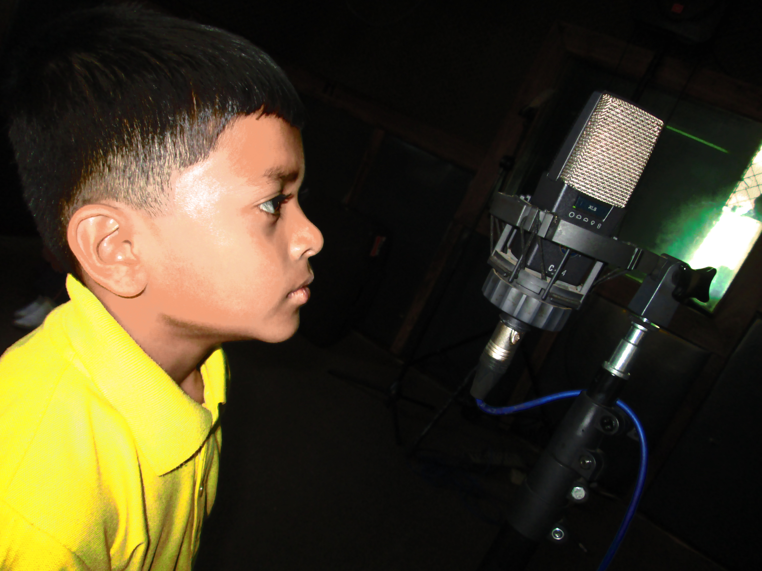
Given the last statement above, we would like to add an important point here. WE KNOW that some schools struggle because no matter what they cannot get proper recording facilities to work with. This was true last year with two of our VATW family of schools in Africa. They didn’t have what they thought were ‘proper’ microphones and felt they didn’t have any fancy equipment with which to record. HOWEVER, with out help and advice, they managed to make some reasonable vocal recordings which we included on the final mix. Here is what happened:

The teachers of course had smart phones and mini earphones. We advised to use one smart phone to playback the mp3. Two students shared the mini earphones (each with an earphone bud in one ear). A second smartphone, in this case and Iphone, was used as to record using the voice recording app on the phone – In this way we successfully received and mixed the voices of the 20 students in the choir on 10 separate recordings. The very interesting point here is that the recording quality of the Iphone used, while perhaps not up to the standard of a studio recording, was very reasonable and, from our point of view definitely usable.
Key teaching tip: Don’t let a lack of the latest all singing and dancing equipment stop you from participating in the project. There is always a way to get a recording, as long as you have a smartphone or a laptop to hand – this also doubles as a way to get some video clips!

Getting used to singing while wearing earphones
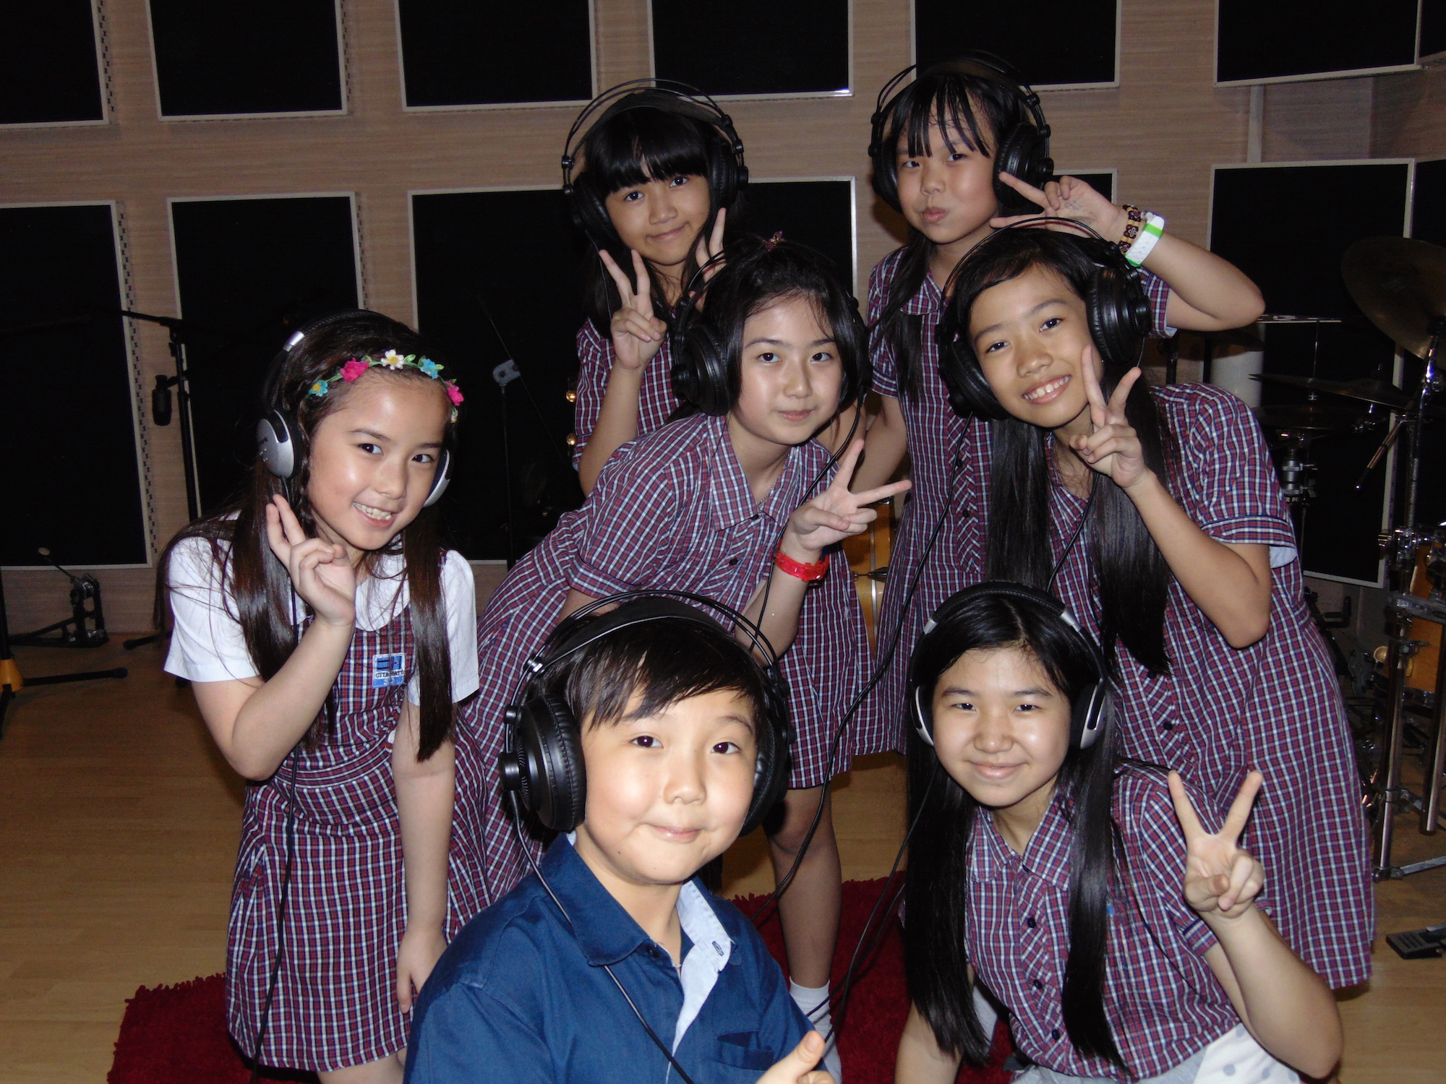
This requires practice. Many people/students find this hard at first especially as they cannot hear their own voice in the same way as usual and this can raise vocal tuning issues. This improves with practice. It may be useful for some students to experiment with pulling one earphone off on one side so that they can hear their own voice and the voice of others while they sing. If you look at the VATW site photos page you will notice some students doing just this!

Earphone leakage – the enemy of all live recording sessions
This is when the sound from earphones is picked up by the microphone you are using i.e. in this case the guide demo track your students are listening to while they sing, is picked up on the recording. Try to eliminate/reduce this as much as you can. It is obviously made worse when the students are close up to the microphone. The more you can reduce this the better the quality of the recording for mixing on to the final track.

Fool proof recording
This feels a little like stating the obvious, but it is worth reminding ...... that when recording choir parts, make sure your students are listening to the demo track as a guide. To inspire yourselves before you record you could enjoy watching the YouTube video of the studio session for recording ‘We Are The World’. This is a great resource and makes a superb music quiz for older students …can they recognise these icons of the music industry …..you are helped by the credits rolling at the end of the clip! http://youtu.be/M9BNoNFKCBI

How to get as close to a ‘pure voice’ sound as possible
We need the voices of your choir to put on the final master recording. This means that your recording(s) should only be voices! In other words, we do not want a recording of your choir that includes the backing track in the background. This would lead to quite an unpleasant sound when we come to put all the recordings together – making the final mix. We want you to set up your recording so that the students listen to the backing track on earphones while singing. This of course pretty much mirrors the way it is done in professional recording studios. ‘WOW that sounds difficult’ we hear you say! NO not at all....here is what you do:
1. Ensure you have reasonable quality recording equipment. A basic microphone and recorder should do the job. Nowadays, these pieces of equipment are easily available at reasonable prices if you do not already have them. You may also find somebody in your school parent community who can help out – there is usually at least one home-musician-studio-geek in most school parent communities!!!
2. You need to have sets of earphones and a junction box/junction boxes....the more the merrier! See the picture of a typical junction box below ... this feeds from the sound source where you are playing the choir part MP3s while the students sing.

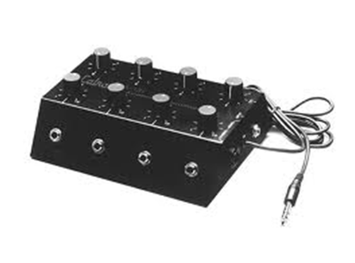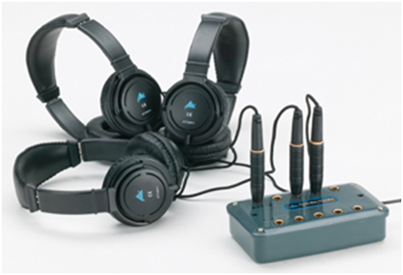
This approach means that you can record groups of your choir singing ...the number of groups you record will depend upon the number of earphones you have available ... the more earphones you have ....the fewer the groups. Working in this way means that when you record, your singers can hear the music backing, but the recording only captures their voices. Within reason we are happy to accept any number of recorded groups from you. All of your recording submissions should be in wav file or MP3 format.
Recording groups.
The groups that you record will require some forethought. The obvious format is to require different sections of your choir. However, you will inevitably have some variations in the quality/confidence of your singers. We have sometimes found ourselves breaking sections down i.e. a stronger section of the best singers recorded, then other groups where some of the best singers support the singing of less confident individuals (so they get to sing two times or more!!!).

Soloists
Yes please - We are always happy to receive recordings of soloists if you have some especially high quality individuals - this gives us the scope in the mixing process to bring a few individual voices to the foreground of the mix if appropriate – this is an aspect that we hope will feature again in this years final for 2019. It was really useful in our last song video release of ‘Sunshine’ if you listen to this carefully, you will notice a few great vocalists in the front line of some parts – especially towards the end of the song. https://www.youtube.com/watch?v=NOlxHWaC4vc

Improvisation …..OH YES PLEASE
Do you have any budding Ed Sheerans or Adeles? Again using the example of our ‘Sunshine’ recording – we had a few very talented vocalists who put their own ornamentation on the vocal line, and, again you will see that this was featured on parts of the recording! HOWEVER…there are obvious cautions here with the burning question of whether their singing ornamentation/interpretation fits with the choir version as a whole. We would definitely encourage you to let any of your students try this. Have a listen to the way our vocalist Julie puts the ornamentation in on the final chorus section of this year’s template for What Kind Of World Are We Trying To Make

Planning the recording session
Here is an imaginary example of a recording plan of a choir. The music teacher has sorted out soloists, strong groups and groups that need support
The altos are the first section to record, and they listen to and sing along with their relevant choir MP3 part, aligning their voices with the vocals on the track as closely as possible. The other choir sections follow on in the same way.
Choir sections | Recording Track
Part 1 – group a | 1 wav/mp3 audio recording
Part 1 – group b | 1 wav/mp3 audio recording
Part 1 - 2 individual solo recordings | 2 wav/mp3 audio recordings
Part 2 group a | 1 wav/mp3 audio recording
Part 2 group b | 1 wav/mp3 audio recording
Part 2 group c | 1 wav/mp3 audio recording
Part 2 - 3 individual solo recordings | 3 wav/mp3 audio recordings
Part 3 group a | 1 wav/mp3 audio recording
Part 3 group b | 1 wav/mp3 audio recording
Part 3 – 2 solo recordings | 2 wav/mp3 audio recordings
How to get the best sound - the recording environment
It is well worth choosing the room in which you record very carefully. Smaller rooms with soft furnishings will often give the best results.
Microphone placement - The distance of your singers from the microphone is important and it is worth experimenting with this a little. It varies a bit from microphone to microphone. Successful recordings we have done in the past have been with students arranged in a semicircle around the microphone so that they are all a similar distance away. About a metre from the microphone is often about right for choir work. It will be good if you are able to monitor the sound levels and quality using earphones yourself, and adjust choir positions/proximity to the microphone accordingly. In particular, watch out for any singer with a much louder voice than others and adjust their standing position if necessary. You may find this problem is exacerbated because students may sing differently with earphones on (known as the IPod syndrome!). Be careful that you do not ‘over record’ i.e. have a recording level that causes distortion of any sort – this would make the recording unusable for us.

Key teaching tip: Your singers do not have to sing loudly
The joy of audio recordings with microphones is that you do not need to sing loudly – pitch, timing and tone are far more important. The volume of your singers can of course be boosted by our equipment as necessary during the mixing phase. As mentioned above ‘over recording’ and distortion are the main ‘enemies’. In the process of finally mixing vocal submissions we can usually work with recordings that were rather low volume – boosting the volume with our studio equipment. Sadly, there is very little that can be done with distorted/over recorded submissions.
Key teaching tip: A really great choir/music teacher we know once said to us ‘Good singing starts from the feet!’ By this he meant a) students sing better when they are standing b) they need good feet placement so they feel steady and relaxed c) surprisingly, occasional foot movement noises can easily creep through onto a recording d) watch out for avoiding foot contact with any microphone stand. You might think we are being pedantic by now, but you would be amazed at how many noises of this sort we have had to clip out of recordings submitted ….talking of which we come to the subject of extraneous noise……
Extraneous noise
You will need to take care that there are no extra sounds on the recording. There are many hazards in any school environment for someone trying to make a recording! Typical problems can be school bells, kitchen or air conditioning equipment and …..of course …PEOPLE! We have had some interesting recordings sent in at times…one actually had chickens clucking in the background!

Specific teaching points
- Note sliding. Wherever possible get your students to hit the notes accurately and avoid the habit of sliding up to or down to a note. Good breathing is often the secret of success in this respect.
- Get your students to focus on the main underlying rhythm – drum beat – bass line to help them keep in time - you may find it helpful to get your students speaking the words together during practice to ensure they are using the precise rhythm as shown on the demo recordings.
Key teaching tip: Get students to listen to the strong pumping base lines in the choruses in the song and ensuring they are in time with this and the demo vocals on the MP3s
How to submit your recording(s) - Uploading your choir recording(s) to Dropbox
Success! You have managed the recording and are all feeling pretty pleased with yourselves …and rightly so! Now the puzzle of how to submit these valuable recordings to us!
Firstly to say - please, please, please do not send the recordings and especially videos by email.

By far the easiest method is to go to the Voices Around The World Website Home Page and click on the Choir Resources/Upload your files here tab. Then just follow the instructions to drag and drop your files.

Slightly more long-winded, but preferable for some Using Dropbox
One of the best systems we have come across for sharing recordings/files is the Dropbox system. This is a free internet programme. If you are not already a member of Dropbox, simply go to their website https://www.dropbox.com/ and download their software and you will be ready for action.

Also many International schools are now using Google Drive or MSN Sharepoint – which we can also work with.

Downloading the Dropbox software

Setting up your folders
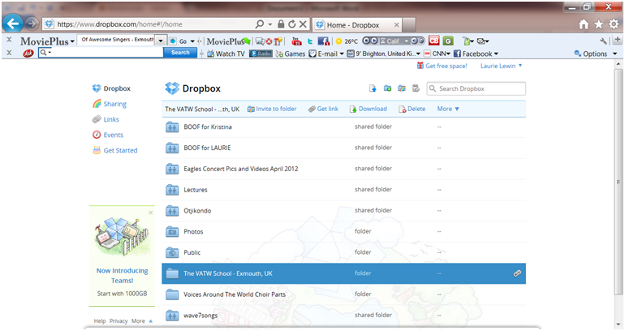
This is a snap of our current Dropbox. We have lots of folders, but you only need one for this project. Simply click on the add folder option in the menu at the top of the screen. It is very important that you clearly label your folder. This is how we will identify your school choir. You will see on the screen snapshot above, we have created an example folder called ‘The VATW School – Exmouth, UK.’

Uploading your files
Whatever device you have used to record your choir parts, you will need to save the audio files onto the computer on which you have installed Dropbox. You can then save your audio files easily to Dropbox. Those of you who are pretty ‘wizzy’ with things ICT will have realised that Dropbox cleverly creates a folder space on your computer as well as on the web. Whatever you copy to the Dropbox folder on your computer, provided you are connected to the internet, automatically gets copied onto your web Dropbox Folder and vice versa. Warning: remember the same applies to deleting folders!!!
Key teaching tips: Make sure you are connected to the internet when saving files to Dropbox (sorry – obvious….but sometimes missed!). Once uploaded – please do not delete files until after the project has ended for this year. Also obvious but often missed – do not switch off/close down your computer until the files have uploaded to Dropbox. Depending on your local internet speed it can take some time for files to upload -especially video files.
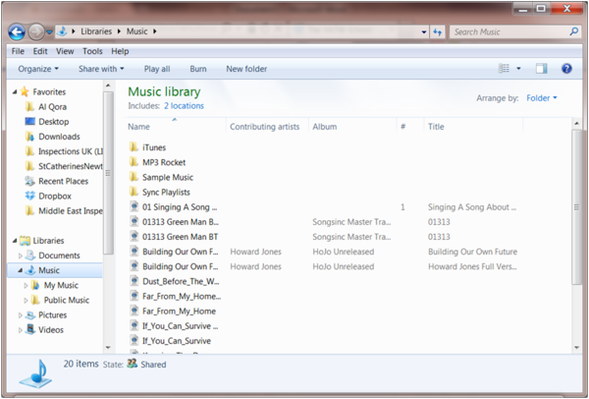
So just go ahead now and save your choir recordings to Dropbox on your computer. (Make sure you are connected to the internet.) We recommend keeping a backup somewhere safe of your choir recordings in case of computer crashes etc.
By now you should have something like the screenshot below shows. The final step is to share your files with us so that we can download them.
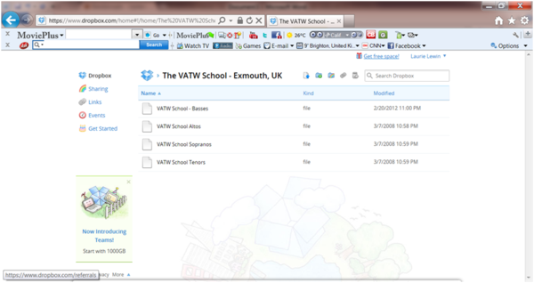

Sharing your folders with us
As indicated, click on the rainbow coloured icon. And you will get the screen below opening:
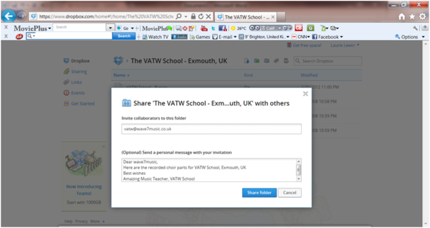
You need to put the email address voices@voicesaround.com in the first box and any relevant message in the box below – to show which school you are.

Labelling the files that you send to us
It is a very big job here at VATW collating all of the tracks and files that get submitted to us. It is enormously helpful if you name your file/files using the following example:

Name_of_School/s_in_full_Town_Country_Part1

To submit your video to us please follow the Dropbox instructions above.

Section 3 – Working with another school/Schools
Over the last four years, we heard some very encouraging stories about schools that had linked with other schools for the project and produced some amazing results and carried out some great joint activities together. We want this idea to grow. For example, The students at the International School of Riga in Latvia told us how they did much work with a Latvian Orphanage organisation and would like to bring this particular organisation into working on the song with them. Panaga School in Brunei also led the way in drawing in local schools in their region to work with them. We very much hope that in working on the project this year you will be able to achieve something similar. Please let us know of any collaboration of this nature when you submit your recordings in March 2019.

Section 4 – Fundraising To help our charity work in Tanzania
So far, over the last two years, VATW has contributed to the work of helping the development of St Mary’s School in Tanzania. Here are some of things that have happened:
- Steering group formed to support the school’s development
- Two new classrooms built
- Avocado trees extensively planted – to help agriculture and sustainability in the project by linking up with the people in Njombe
        - New sports ground built

- In recent times three UK teachers went over to the school and spent two weeks providing training for the teachers there, helping with current development planning. While there, they recorded songs with the children. VATW provided 20 MP3/4 players for the school to help the process of learning ours and other songs.
- £12,000 raised by VATW downloads and other fund-raising activities helped us to build outside sports areas for the school and provided IT equipment and books
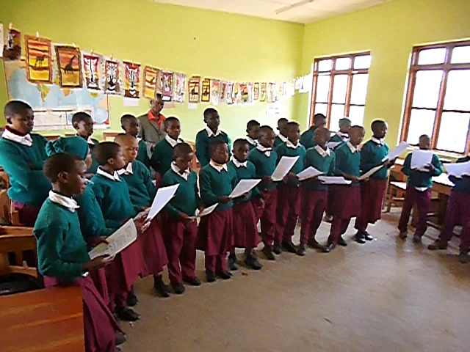
Njombe Children learning to sing one of our songs, which they went on to record for us!
Join us with boosting the fund-raising for St Mary’s School in Njombe. Help these children – many of whom have been orphaned by the HIV virus which is rife in this part of Africa.
Many amazing VATW schools have agreed to run a fund-raising event during 2018/19, join this exclusive club of fantastic schools and run your own fund-raising concert.
We hope that you will feel like joining in this very worthwhile cause. How amazing is it for our students to sing their hearts out at the same time as raising funds to help these very needy young people in Njombe. If you wish to join in with us on this please drop a line to info@voicesaround.com and in return we will provide you with lots of extra free choir and display resources. Let’s all make 2018/19 an AMAZING YEAR for the Njombe children!

